**Designing The SetPaperFrame**

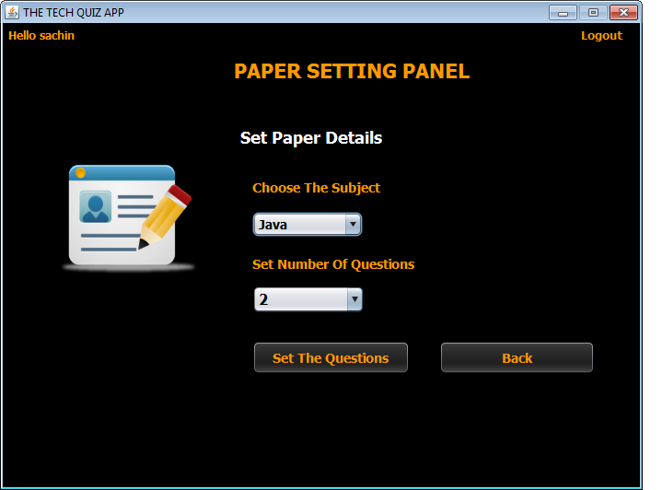

**STEPS TO BE DONE IN** **SetPaperFrame**

In the **SetPaperFrame** we need to do following steps:

1. Display **username** on the top left

2. Allow the user to **logout**

3. Write code for the "**Set Questions**" Button . When this button is clicked it should:

a.Generate an **Exam-Id**

b.Pass the **Exam** details(**Exam Id**,**subject**,**total no of questions**) to the **SetQuestionsFrame**

4. When the "**Back**" button is clicked we must go back to the **AdminOptionsFrame**

**Displaying The Username**

Same as AdminOptionsFrame

**Allowing The User To Logout**

Same as **AdminOptionsFrame**

**WRITING THE CODE FOR BUTTON Button.png IN SetPaperFrame**

**Generating The Exam-Id**

To generate the **Exam-Id** , we use a simple logic:

**a. Find out number of rows in the EXAM Table**

**b. Add 1 to rowcount and prefix it with "EX" which is the new Exam-Id. For example if total rows in the EXAM Table is 3 then next Exam-Id will be "EX-4"**

**How To Find Number Of Rows**

To find number of rows in the **EXAM** Table we do the following:

a. Create the ExamDAO class with a method called getExamId( ).

b. This method should execute the following SQL query:

*"Select count(*) as totalrows from Exam"*

and return value of count(*) +1 as the Exam-Id prefixed with "EX"

c. So the prototype of the method is:

***public static String getExamId()throws SQLException***

Following is it's code:

***public static String getExamId()throws SQLException{***

***String qry="Select count(*) as totalrows from Exam";***

***int rowCount=0;***

***Connection conn=DBConnection.getConnection();***

***Statement st=conn.createStatement();***

***ResultSet rs=st.executeQuery(qry);***

***if(rs.next())***

***rowCount=rs.getInt(1);***

***String newId="EX-"+(rowCount+1);***

***return newId;***

***}***

**Opening The SetQuestionsFrame**

To open the **SetQuestionsFrame** we need to pass it the **Exam** details. This is done as follows:

**a. Create a POJO class called Exam**

**b. Create an object of Exam POJO and store Exam-Id, language and total questions in it.**

**c. Pass it to the SetQuestionsFrame constructor**

**d. Dispose the current Frame**

**The class Exam:**

***public class Exam {***

***private String ExamId;***

***private String language;***

***private int totalQuestions;***

***public Exam(String ExamId, String language, int totalQuestions) {***

***this.ExamId = ExamId;***

***this.language = language;***

***this.totalQuestions = totalQuestions;***

***}***

***public String getExamId() {***

***return ExamId;***

***}***

***public void setExamId(String ExamId) {***

***this.ExamId = ExamId;***

***}***

***public String getLanguage() {***

***return language;***

***}***

***public void setLanguage(String language) {***

***this.language = language;***

***}***

***public int getTotalQuestions() {***

***return totalQuestions;***

***}***

***public void setTotalQuestions(int totalQuestions) {***

***this.totalQuestions = totalQuestions;***

***}***

***}***

Following is the complete code for "**Set The Questions**" Button

***private void btnSetActionPerformed(java.awt.event.ActionEvent evt) {***

***String subject=jcLanguage.getSelectedItem().toString();***

***int totalQuest=Integer.parseInt(jcQuestions.getSelectedItem().toString());***

***int ans;***

***ans=JOptionPane.showConfirmDialog(null, "You have chosen \""+subject+"\" and \""+totalQuest+"\" questions!\n Is this OK ?","Conformation!",JOptionPane.YES_NO_OPTION,JOptionPane.QUESTION_MESSAGE);***

***if(ans==JOptionPane.YES_OPTION)***

***{***

***try{***

***String examId=ExamDAO.getExamId();***

***Exam newExam=new Exam(examId,subject,totalQuest);***

***SetQuestionsFrame questionsFrame=new SetQuestionsFrame(newExam);***

***questionsFrame.setVisible(true);***

***this.dispose();***

***}***

***catch(SQLException ex){***

***JOptionPane.showMessageDialog(null, "Error while connecting to DB!","Exception!",JOptionPane.ERROR_MESSAGE);***

***ex.printStackTrace();***

***}***

***}***

**WRITING THE CODE FOR BUTTON Button.png IN SetPaperFrame**

***private void btnBackActionPerformed(java.awt.event.ActionEvent evt) {***

***AdminOptionsFrame adminFrame=new AdminOptionsFrame();***

***adminFrame.setVisible(true);***

***this.dispose();***

***}***